Name:_____________________________ Date:_____________

Civil Rights Computer Project

Objective: You are going to create a podcast that reports on a major event from the Civil Rights Movement.

Directions: From Mrs. Kennedy’s R180 website, choose an event to research. Then complete the research questions below. Once your research is completed, you will be able to record your podcast using PhotoStory. You will need 6 to 8 photos for your podcast.

**Part 1:**

**Due:__________________**

Topic: ___________________________________

[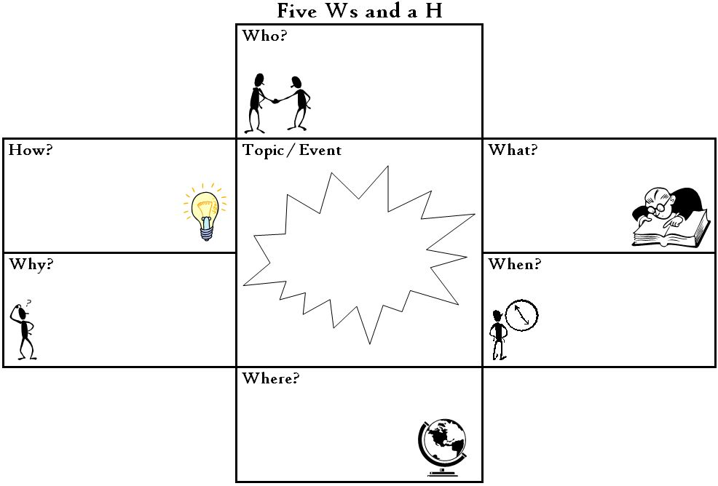](http://www.google.com/url?sa=i&rct=j&q=&esrc=s&frm=1&source=images&cd=&cad=rja&uact=8&ved=0CAcQjRxqFQoTCIm7tNmnq8gCFQptPgoduIUBTw&url=http://margdteachingposters.weebly.com/graphic-organizers.html&psig=AFQjCNEFiCASB5AjeKaxqDGfow7-6ovXtw&ust=1444133667652494)

Part 2:

Due:__________________

**Directions:** Fill in the graphic organizer below using details from your research.

Problem

Who?

What?

Why?

|  |  |
| --- | --- |
| Attempted Solution | Result |
|  |  |
|  |  |

Attempts

Solution

In your opinion, was the solution successful? What text based evidence supports your response?

Evaluate

Newspaper Article Planner

Name: ______________________ Event: _____________ Due: _________

Article Title: _________________________