Name:________________ Date:______
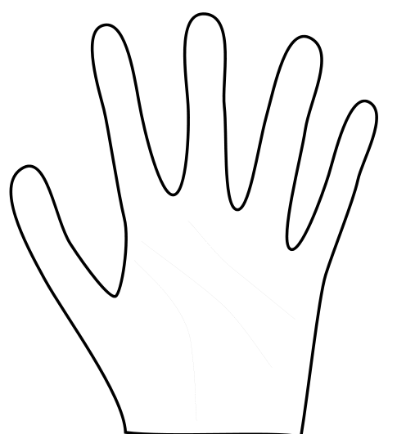
Main Idea

What When Where

Why

Who

How

The main idea is __________________________________________________________________________________________________________________

Name:____________________ Date:______
Main Idea and Details Chart

Main Idea Question | Main Idea | Detail
Who?

What?

When?

Where?

Why?

How?

