The following rules apply to a parallel circuit:
- The potential drops of each branch equals the potential rise of the source.
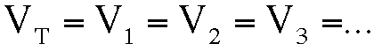
- The total current is equal to the sum of the currents in the branches.
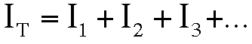
- The inverse of the total resistance of the circuit (also called effective resistance) is equal to the sum of the inverses of the individual resistances.
