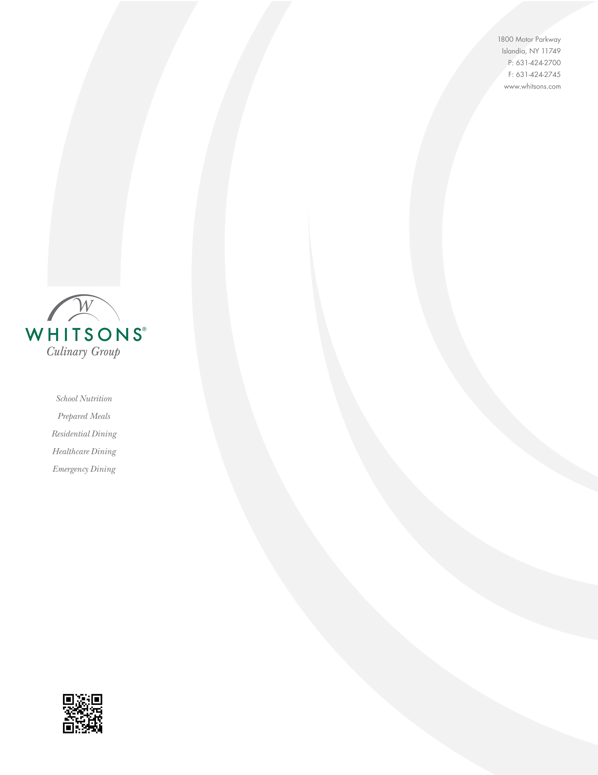

08/12/24

Marilyn DiGregorio
General Manager
Whitsons

Dear Parents & Students,

I would like to make you aware that if you like to put any restrictions on an account for Breakfast and/or Lunch you can contact me at
845-895-7192 or e-mail me at digregoriom@whitsons.com and I will make sure that the restrictions are listed.

As a reminder students can get 1 complete breakfast and 1 complete lunch for FREE!

Thanks so much and I look forward to the start of a new year!

Sincerely,

Marilyn DiGregorio
General Manager

